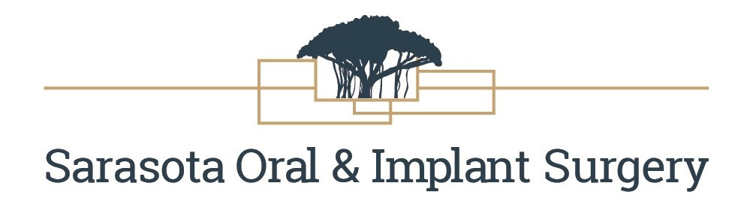

POST-OPERATIVE INSTRUCTIONS
Medications: Resume antibiotics after dinner the evening of your surgery and take until finished. If Medrol (Steroid-taper pack) was given start the morning after surgery and take as directed on the back of the package.
Bleeding: Expect minor bleeding or oozing from the surgical site (saliva will be pink in color). To minimize this, keep the gauze that was placed at the surgery on the area for 30-40 minutes. REMOVE THE GAUZE and only reapply if the surgical site is still oozing. Once the oozing has slowed down DO NOT replace the gauze or place any other irritant near the surgical site as this will only increase oozing and discomfort. If you experience ACTIVE continuous bleeding please call the office and a member of the surgical team will assist you. Avoid strenuous activities until you are no longer taking the narcotics. Avoid hot stimulants such as coffee and/or tea for the first 24 hours.
Diet: Keep taking nourishment. Always think COLD for the first 24 hours. Avoid using straws as the suction can dislodge clots or sutures. Soft foods are the best to eat for the first few days following your surgery. Examples: pasta, scrambled eggs, mashed potatoes, yogurt, Ensure drinks, smoothies, milkshakes, oatmeal. Avoid crunchy foods such as chips or popcorn for a minimum of two (2) weeks.
Pain: Discomfort is anticipated following surgery and begins as the anesthetic wears off. It is best to use pain medication PRIOR to the onset of pain while the area is numb and administer the first dose with some food to avoid nausea. Medication should not be taken on an empty stomach. Continue the dosage as directed-typically every 3-6 hours as prescribed. Take medication with a full glass of water and after eating. DO NOT drive or operate machinery while taking prescription pain medication. Please be aware that surgical pain often intensifies over the first 2-3 days.
Brushing/Rinsing: Resume brushing your teeth and maintaining good oral hygiene. Avoid directly brushing/flossing the surgical area. The provided H2Ocean/saltwater soaks will keep the surgical site clean. Avoid vigorous rinsing of the mouth. Instead, soak with the H2Ocean rinse 3-4 times daily. This should start the night of your surgery and should continue until instructed the bottle is empty. If you run out of the H2Ocean you can rinse with regular salt water or purchase a bottle of the H2Ocean in our office.
Bruising/Swelling: Swelling and bruising following surgery is expected. Blood thinners and/or non-steroidal medications will increase bruising. To help reduce swelling apply an ice pack adjacent to the surgical area for the first 24 hours. This should be done for 20-30 minutes on and off to avoid freezing the tissues. After 24 hours transition to the application of warm moist heat. Peak swelling will occur between days 3 and 5. Do not be alarmed by this as it is normal. Be aware that swelling will increase before it plateaus and eventually resolves.
Bone Graft/InFuse Bone Graft Patients: Peak swelling and bruising can and are often delayed-don’t be alarmed. Dependent upon the graft type swelling will progress after surgery and typically peak at day 5. Some grafts induce bone growth and generate sustained swelling for 10 days. This is particularly true of InFuse grafts. You may find some small granules in your mouth for the first several days. Do not be alarmed by this as it is normal.
Temperature: There may be a slight elevation of temperature (98.6°-100° F) for the first 48 hours after surgery. This is common and is not infection related but an after-effect of deep/general anesthesia. It is important that you drink adequate amounts of fluid (water/juice).
Pain in other teeth: Following an extraction the surrounding bone, tissues, and associated nerves often become inflamed. This can lead to other teeth in the area becoming sensitive. This is known as Referred Pain and is usually short in duration resolving on its own.
Numbness: After a surgical procedure numbness of the lips or tongue may occur. This is usually temporary and is known as Paresthesia. In some cases, sensation may not be regained for several months.
Stiffness: Stiffness of the lower jaw is known as Trismus. This tends to relax after 3-4 days and can be improved upon with gentle stretching and moist heat. In addition, anti-inflammatory medication such as Ibuprofen may help.
Inspecting the wound: Avoid pulling the lips to see the surgical area or removing any sutures. Doing so can open the wound. During the healing process, the sutures may become stiff and irritable-this is expected. Non-resorbable sutures will be removed at your post-op visit.
REFRAINING FROM SMOKING OR ALCOHOL CONSUMPTION IS A MUST for a MINIMUM of 72 HOURS FOLLOWING SURGERY. SMOKING WILL DELAY AND OFTEN COMPROMISE HEALING.
Denture Patients: Patients that receive immediate dentures/partials at the time of surgery should wear them for 24 hours if possible. Pain or poor retention can prompt their removal prior to this goal but no reason to worry. They can be fitted and/or adjusted by your dentist at a later date.
Emergency: Our offices maintain an answering service to address most after-hour calls. In the event that you need to speak to one of the Doctors after hours, please call the office and a message will be sent to them.

If you are experiencing a true dental emergency, please call 911.

